VaporBooster Operating Instructions

English: French:
VaporBooster Operating Instructions:  Clean cylinder surface to be heated. Remove loose rust, soil and peeling paint.  Ensure there are no sharp protrusions  Strap the VaporBooster around the cylinder surface, towards the bottom part of the cylinder, above the circumferential weld.  Do not plug in until the heater is installed around a metallic cylinder surface that can absorb the heat. It may overheat which could damage the product and may present a hazardous situation. | Ceinture Chauffante VaporBooster; instructions d'utilisation:  Nettoyer la surface du cylindre à chauffer de toute rouille, terre ou de peinture detachable.  Securisez la ceinture chauffante VaporBooster autour de la bouteille de gas, vers la partie inférieure du cylindre.  Ne branchez pas lorsque la ceinture chauffante n'est pas installée autour de la surface d'un cylindre métallique qui peut absorber la chaleur, ou la sur-chauffe peut endommager le VaporBooster, et pourrait évoluer vers une situation dangereuse.

Spanish: German:
VaporBooster instrucciones de uso:  Limpie la superficie cilíndrica. Elimine el oxido, suciedad, y pintura desconchada.  Até el VaporBooster alrededor de la superficie cilindríca, en la parte baja del cilindro.  No lo conecte a la red eléctrica si no está instalado alrededor  De una superficie metálica cilíndrica que pueda absorve el calor generado, podría dañar el producto, o llevarle a una situación peligrosa. | 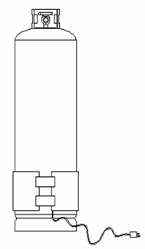 | VaporBooster Bedienungsanleitung  Reinigen Sie die Zylinderoberfläche, die aufgeheizt werden soll .  Entfernen Sie Rost, Schmutz und abblätternde Farbe.  Jetzt wird der VaporBooster um die Zylinderoberfläche zum unteren Teil des Zylinders hin festgezurnt.  Achtung! Nicht den Stecker einstecken, wenn das Heizgerät nicht um eine wärmeabsorbierende Metalloberfläche installiert ist, sonst wird das Produkt beschädigt und es kann eine potentiell gefährliche Situation entstehen.

VaporBooster: Safety Thermostats

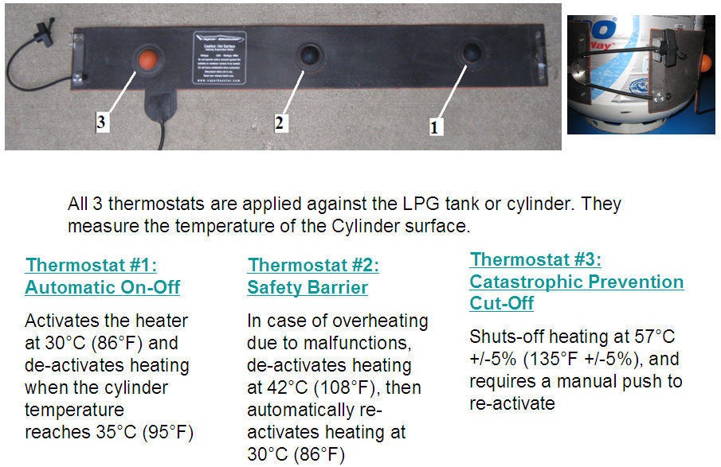

Safety Instructions:
The VaporBooster is designed and constructed in accordance with IEC safety regulations and it complies with UL requirements.
- Ensure electrical supply socket is outside the exclusion zone around LPG cylinders described in AS/NZS1596 or AS/NZS5601.
- Avoid mechanical impact (eg: hammer or tools) or any pinch that could damage the protective silicone insulation and cause damage to the electric heating cables.
- Do not damage or cut the power cable.
- Multiple VaporBoosters may be used on a cylinder. Do not overlap two heaters. Install with a 5-10mm spacing.
- Do not pull the gas tank by pulling the VaporBooster electrical cord.
- Remove VaporBooster from gas cylinder when transporting.
- Only use when the cylinder is vertical, do not use when if the cylinder is horizontal, so that the VaporBooster heats only the area that is in contact with the liquid portion of the gas.
- If necessary to clean your VaporBooster, clean with warm water first, or kerosene if you need to remove asphalt or tar. Do not use other solvents or abrasive cleaners.

Catalyst Quality, LLC , Chicago, IL, USA
Georges Selvais Tel: 224 512 0508 gselvais@gmail.com

